**GitHub+Jenkins+Terraform+Ansible+EC2**

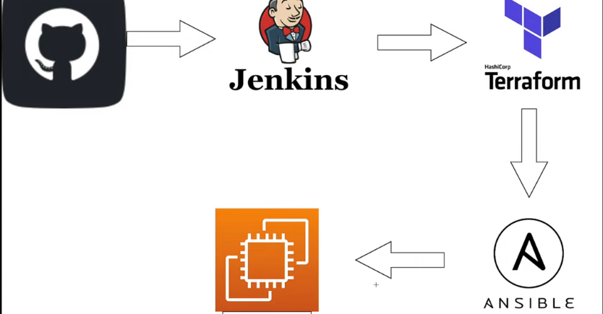

Create a user in IAM with proper permissions to access EC2

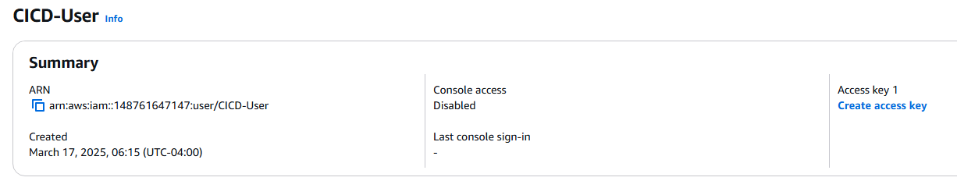

Install Jenkins on Ubuntu and configure Jenkins.

Select Launch Instance on AWS Instance Page.

Give a name and select Ubuntu

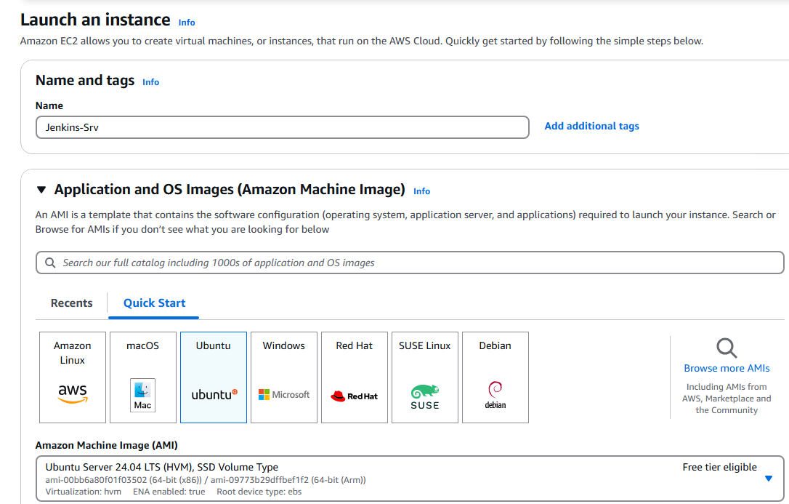

Create or select a Key Pair

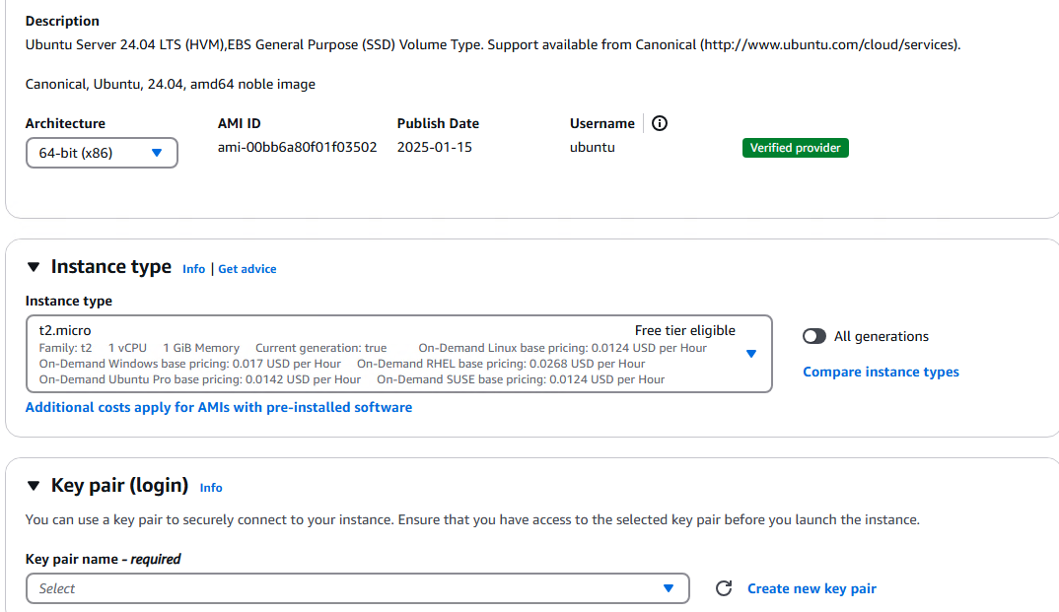

Select VPC and Security group.

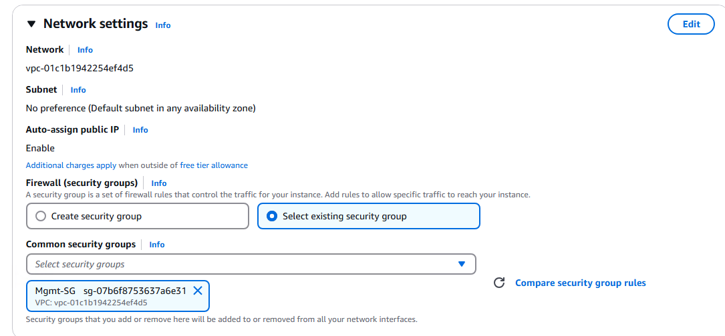

Select IAM Role if you want to access the EC2 instance via Session Manager and launch the instance.

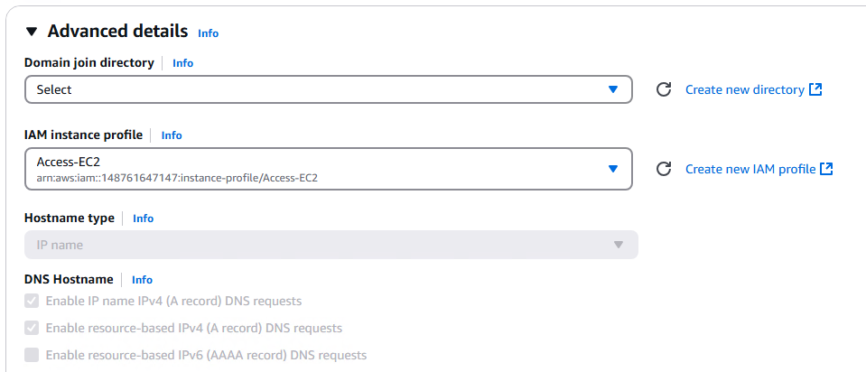

**Install Terraform**

**sudo apt-get install unzip**

**wget https://releases.hashicorp.com/terraform/1.11.2/terraform_1.11.2_linux_amd64.zip**

**unzip terraform_1.11.2_linux_amd64.zip**

**sudo mv terraform /usr/local/bin/**

**terraform --version**

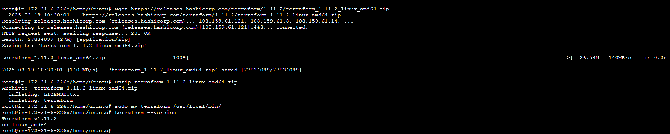

1. **Installing Jenkins**

First, update the default Ubuntu packages lists for upgrades with the following command on the Ubuntu EC2 instance

>>>Sudo apt-get update

Then, run the following command to install JDK 11:

>>>sudo apt-get install default-jdk -y

change the path to /home/ubuntu

run the command:

**sudo wget -O /usr/share/keyrings/jenkins-keyring.asc \**

**https://pkg.jenkins.io/debian/jenkins.io-2023.key**

**echo "deb [signed-by=/usr/share/keyrings/jenkins-keyring.asc]" \**

**https://pkg.jenkins.io/debian binary/ | sudo tee \**

**/etc/apt/sources.list.d/jenkins.list > /dev/null**

**sudo apt-get update**

**sudo apt-get install jenkins**

Once that’s done, start the Jenkins service with the following command:

sudo systemctl start jenkins.service

To confirm its status, use:

sudo systemctl status Jenkins

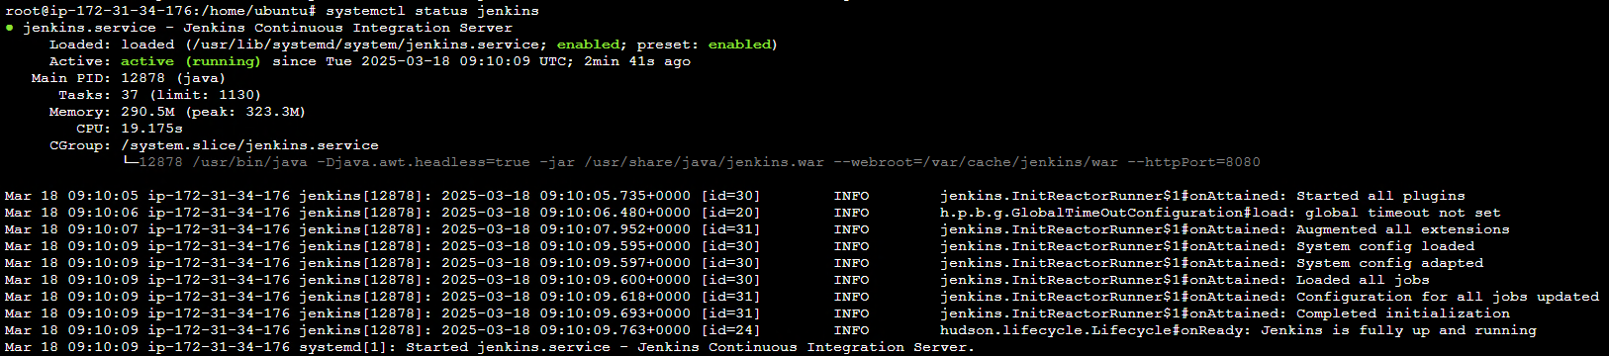

Access the Jenkins with the Public IP of the Instance on port 8080. Make user that the port 8080 is allowed on the security group.

E.g, <http://3.110.195.188:8080>

You can get the password but running the command

sudo cat /var/lib/jenkins/secrets/initialAdminPassword on the Ubuntu machine.

Configure the Jenkins with Credentials and other details.

**Install required plugins**

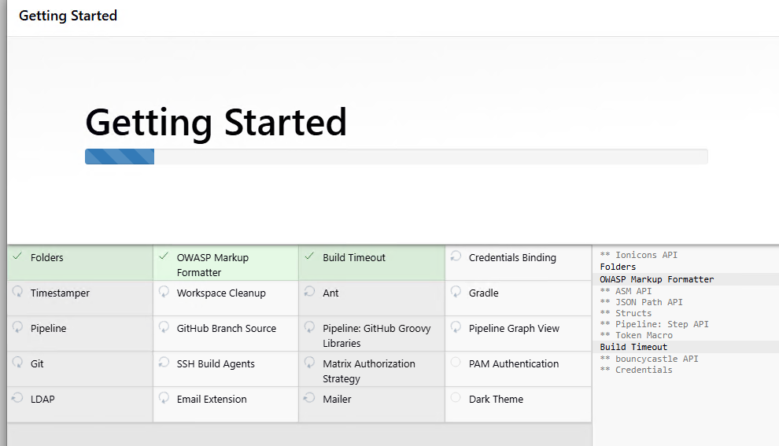

**Create Credentials.**

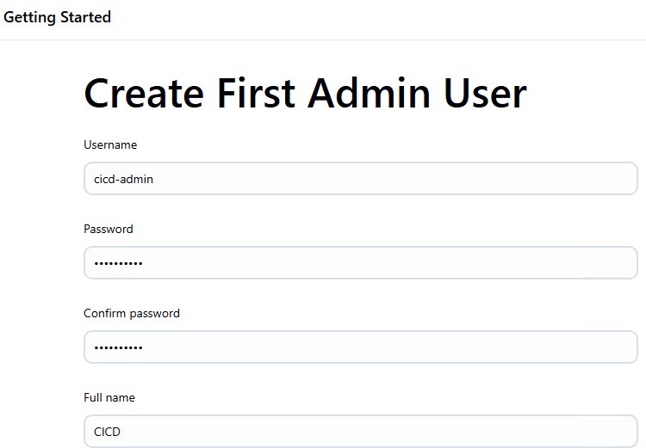

**Configure Jenkins for the Pipeline**

We need to configure the credentials in order to create the Pipe Line.

Go to [Dashboard](http://3.110.195.188:8080/) > [Manage Jenkins](http://3.110.195.188:8080/manage/) > [Credentials](http://3.110.195.188:8080/manage/credentials/) > [System](http://3.110.195.188:8080/manage/credentials/store/system/) > [Global credentials (unrestricted)](http://3.110.195.188:8080/manage/credentials/store/system/domain/_/) to Add Credentials.

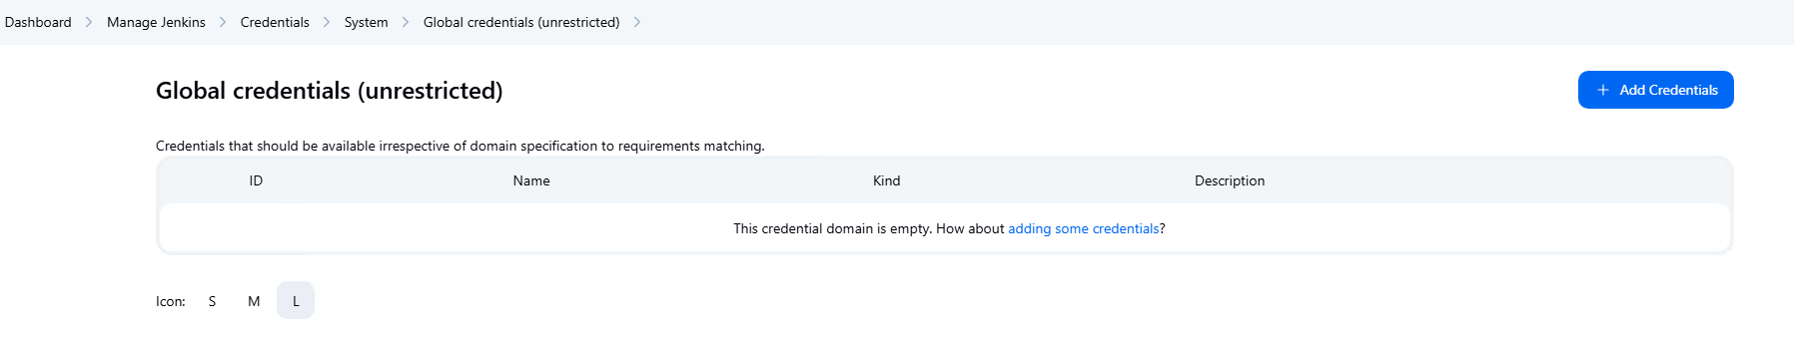

Select Secret Text. We have Jenkins File where we have declared the variables for Access KEY.

Mention the Access Key ID and click on Create

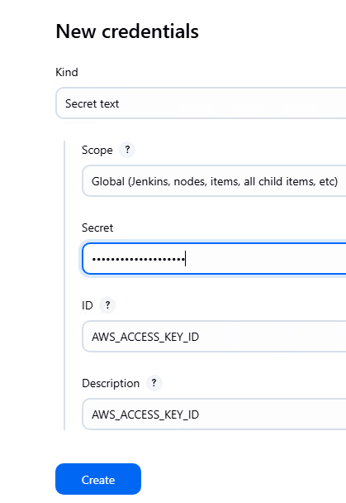

Create one more credential for the Secret Access Key. Copy the secret access key for the newly create user.

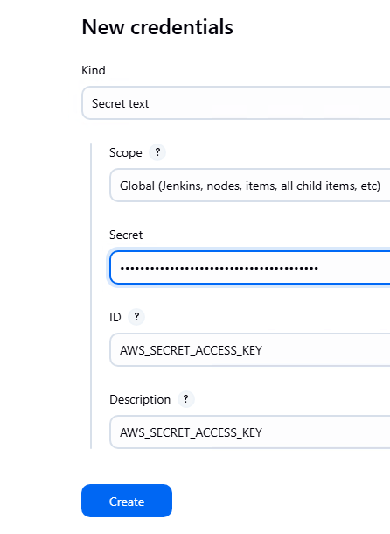

Go to Dashboard of Jenkins and click on New Item.

Provide a name and select PipeLine. Click on Configure

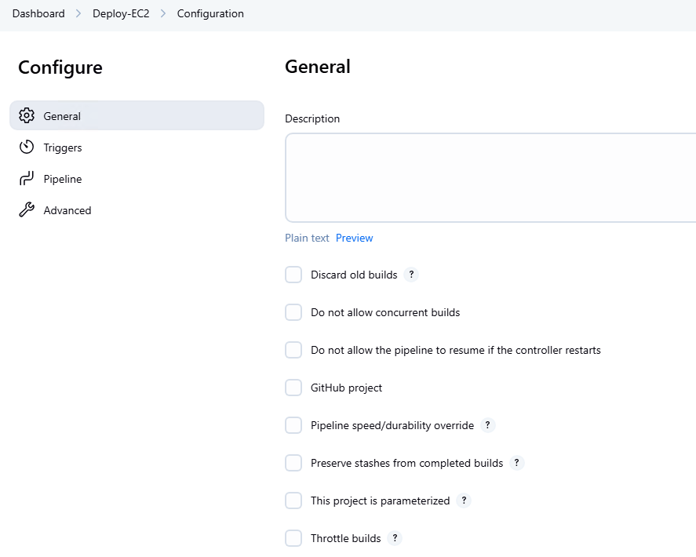

Under Pipeline > Definition select Pipeline script from SCM (Source code Management i.e. Github)

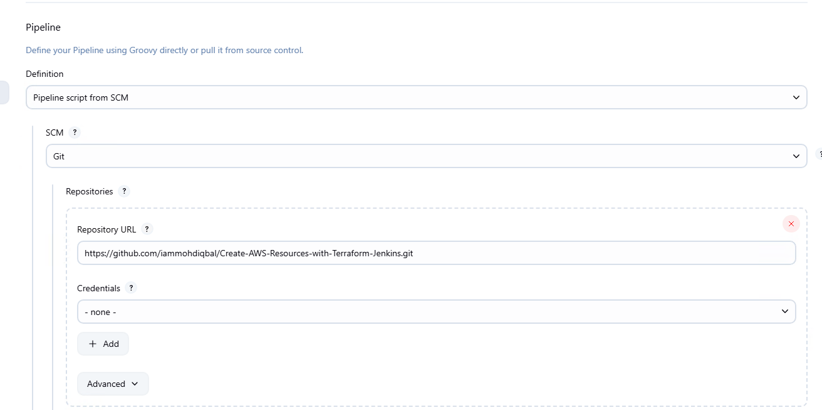

Update the branch and Script Path. Jenkins file is the file where the script is configured.

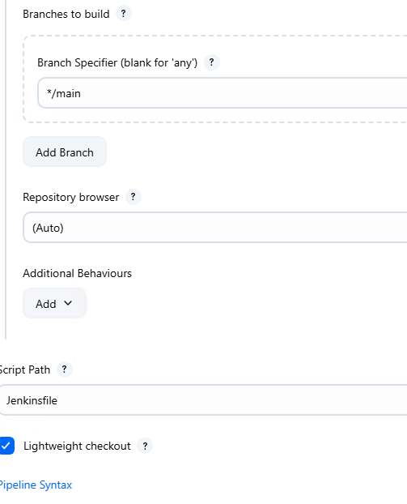

Click on Build Now

The build was successful.

